Learn to Crochet
3 HOUR WORKSHOP - £35
Harrow Way School, Weds 11th July 6.30-9.30pm
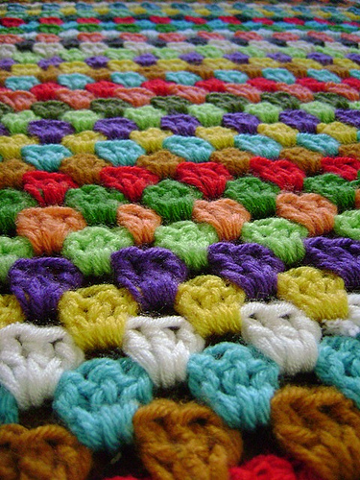
This workshop is suitable for beginners.
Materials required will be supplied.
Call Harrow Way Community Office on 01264 364900 for more information and to book your place

