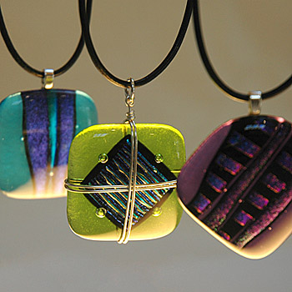
Come along and create an individual piece of Jewellery.

Design and Make Contemporary
Jewellery Course

At

Harrow Way Community School

Starting Monday 16th April 2012
For 6 weeks, 7.00pm- 9.00pm
Costs £60.00
Concessions Available

Limited places available
Call Harrow Way Community Office on 01264 364900 to book your place.

