Fancy spending more time together as a family?
Come along to a Family Cookery Course
At Harrow Way Community School
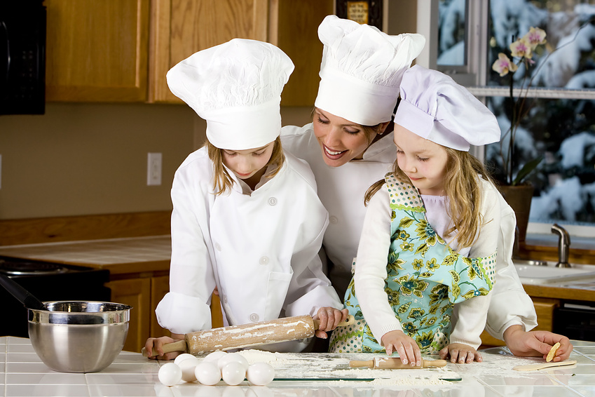
A great course suitable for family members to have fun and improve their culinary skills and confidence when cooking together.
6 Week Course starting on:
Tuesday 12th June 2012 – 5.00-7.00pm
Cost: £60.00 for one adult and one child
(concessions available)
(£10 extra for one additional child) Minimum age 8 years
Limited Places Available
Call Harrow Way Community Office 01264 364900 for more information and to book your place

Call Harrow Way Community Office on 01264 364900 for more information and to book your place

