YOGA IS STARTING IN SEPTEMBER AT HARROW WAY COMMUNITY SCHOOL

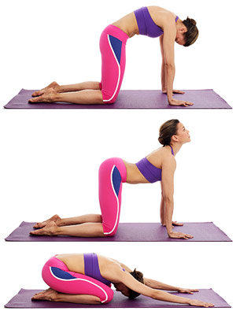

Yoga with Michelle
Thursday
7.30-8.30pm
In the Gymnasium

Cost: £55.00 for 10 Week Course

Limited Places Available
Call Harrow Way Community Office 01264 364900 to book your place.

