PILATES IS STARTING IN SEPTEMBER AT HARROW WAY COMMUNITY SCHOOL

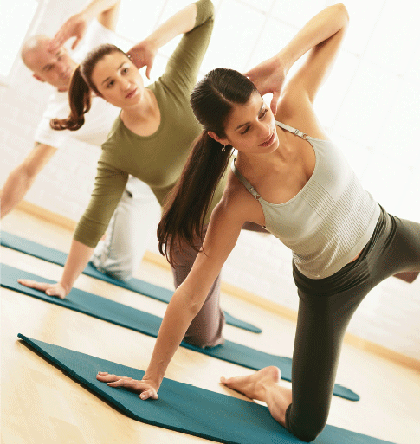

PILATES with Jane
‘Jane combines Yoga and Pilates together, giving you both disciplines in one session – Yogalites’
Saturday
10.30-11.30am
In the Gymnasium

Cost: £55.00 for 10 Week Course

Limited Places Available
Call Harrow Way Community Office 01264 364900 to book your place.

