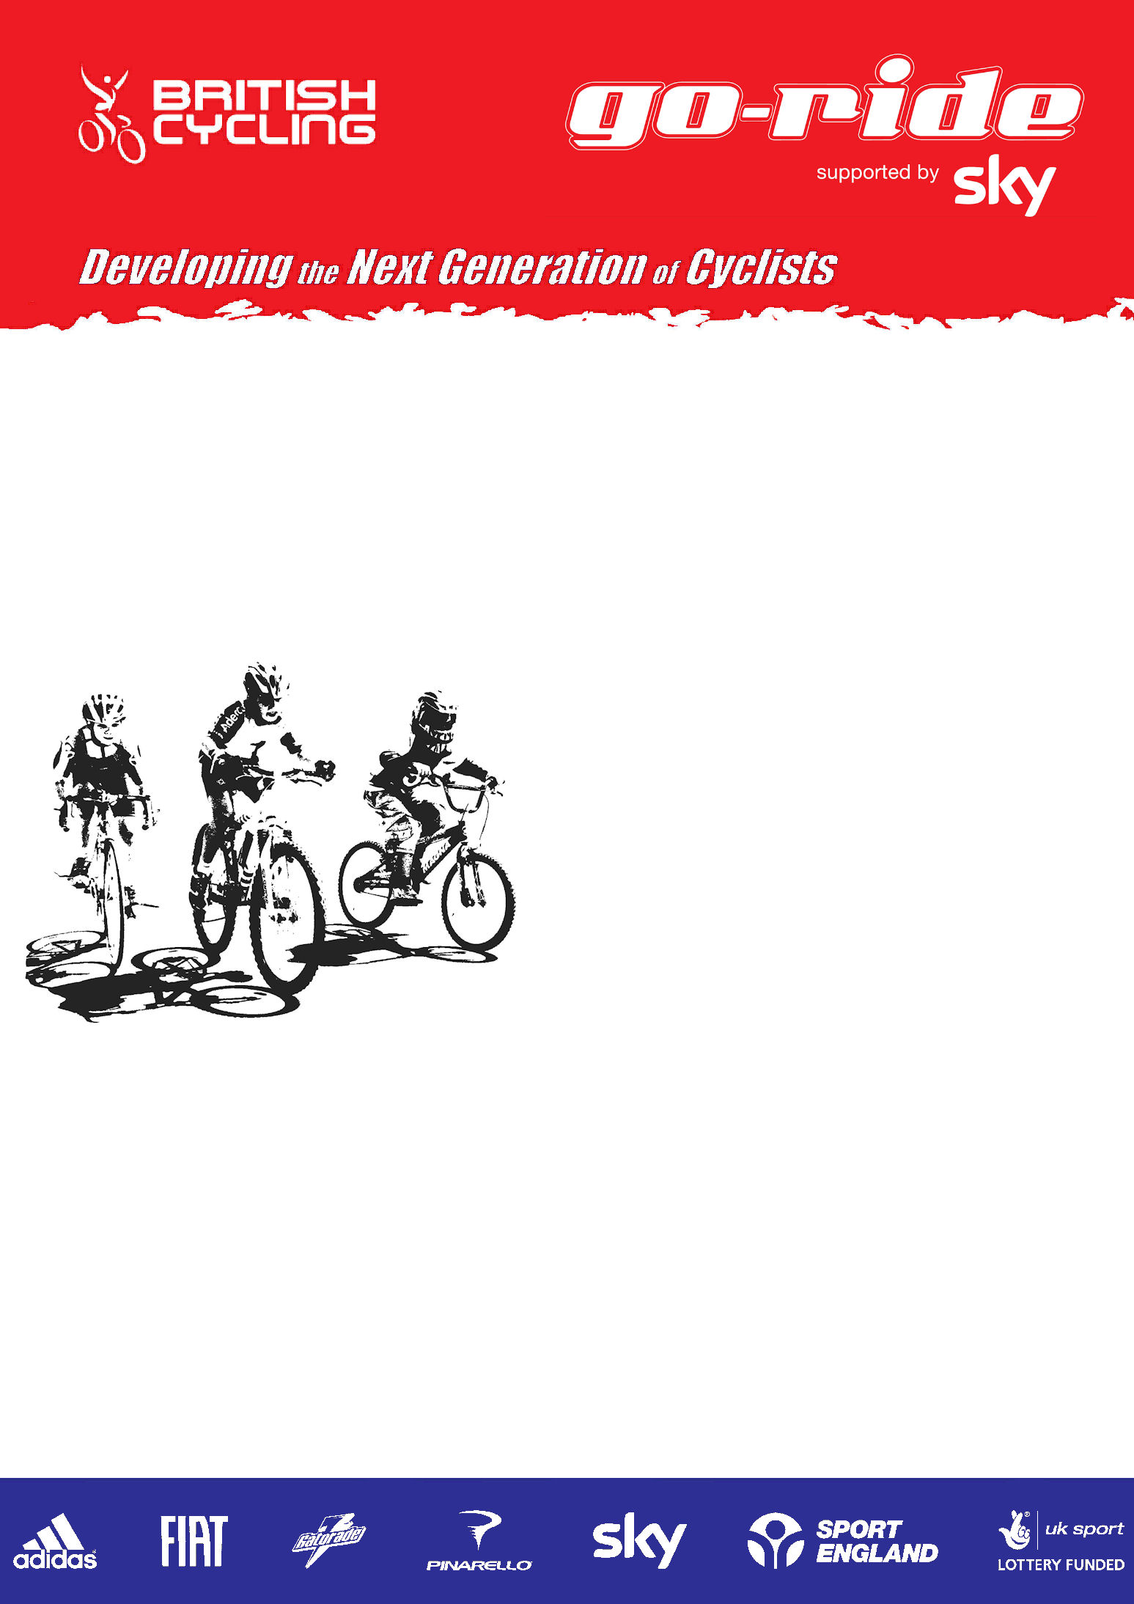
South Coaching Activities 2011

Date of Programmes
17th and 18th August
Type of Session

Go-Ride MTB/Cyclo-cross Skills 2 days

Age Range
(6yrs – 16yrs)

Venue Details/Address

Harrow Way Community School, Andover SP10 3RH

Session Timings
(10:00 – 13:00)

Cost £10.00 per day
Please bring completed registration form on the day
Equipment required, bike, helmet, appropriate clothing, drink, snack

For further information please contact:
Dave Jowett
Mobile Number:
07940433570
Email Address:
davejowett@britishcycling.org.uk



For more information, please call: 0161 274 2070
British Cycling, National Cycling Centre, Stuart Street, Manchester, M11 4DQ
For more information, please call: 0161 274 2070
British Cycling, National Cycling Centre, Stuart Street, Manchester, M11 4DQ
For more information, please call: 0161 274 2070
British Cycling, National Cycling Centre, Stuart Street, Manchester, M11 4DQ
For more information, please call: 0161 274 2070
British Cycling, National Cycling Centre, Stuart Street, Manchester, M11 4DQ
For more information, please call: 0161 274 2070
British Cycling, National Cycling Centre, Stuart Street, Manchester, M11 4DQ
For more information, please call: 0161 274 2070
British Cycling, National Cycling Centre, Stuart Street, Manchester, M11 4DQ
For more information, please call: 0161 274 2070
British Cycling, National Cycling Centre, Stuart Street, Manchester, M11 4DQ
For more information, please call: 0161 274 2070
British Cycling, National Cycling Centre, Stuart Street, Manchester, M11 4DQ
For more information, please call: 0161 274 2070
British Cycling, National Cycling Centre, Stuart Street, Manchester, M11 4DQ
For more information, please call: 0161 274 2070
British Cycling, National Cycling Centre, Stuart Street, Manchester, M11 4DQ
For more information, please call: 0161 274 2070
British Cycling, National Cycling Centre, Stuart Street, Manchester, M11 4DQ
Registration and Parental Consent Form

I being the parent/guardian of __________________________________________ have read the information contained in this notice and hereby consent to my child taking part in the coaching sessions and understand and agree that my son/daughter participates in coaching sessions under instruction by British Cycling coaches entirely at his/her own risk. I have considered the nature of such sessions and have discussed them with my son/daughter. I am satisfied that my son/daughter is sufficiently responsible and competent to assume full and entire responsibility for his/her own safety under the supervision of a British Cycling coach. I am also aware that British Cycling may take photographs/video footage during the Go-Ride activity and give permission for them to be used in various British Cycling publicity purposes.

Signed(Parent/Guardian):______________________________ Date:______________________
Participant Details

Name: ______________________________ Male/Female:____________________________

Date of Birth:___/___/___ School Year:______ School:_________________________________

Address:_________________________________________________________________________________________________

________________________________________________ Postcode:_______________________________

British Cycling Membership Number (if applicable) _____________________

Home Telephone:__________________________________________________

Email Address:____________________________________________________

Do you have a disability? Yes/No If yes, please give details:_______________________________________________________

Ethnicity

White
British □ Irish □ Other white (please state) ____________________________

Mixed
White & Black Caribbean □ White & Black African □ White & Asian □
Other Mixed (please state) _______________________________________________

Asian or Asian British
Indian □ Pakistani □ Bangladeshi □
Other (please state) ____________________________________________________

Black or Black British
Caribbean □ African □ Other black (please state) ____________________________

Emergency Contact Details

Name:________________________________ Relationship to Participant:_________________________

Contact Telephone Number (including area code):_______________________________________
Medical Information

Please make a note below of any medical conditions you feel we need to know about. If you have any concerns about your child participating in any form of physical activity then please consult your GP before giving permission for your child to take part in the Go-Ride Activities.
________________________________________________________________________________________________________
________________________________________________________________________________________________________
Please indicate event name & dates:

Disability
The Disability Discrimination Act 1995 defines a disabled person as anyone with a “physical or mental impairment which has a substantial and long term adverse effect upon his/her ability to carry out normal day to day activities”.

Do you consider yourself to have a disability? Yes ( ) No ( ) Prefer not to say: ( )

