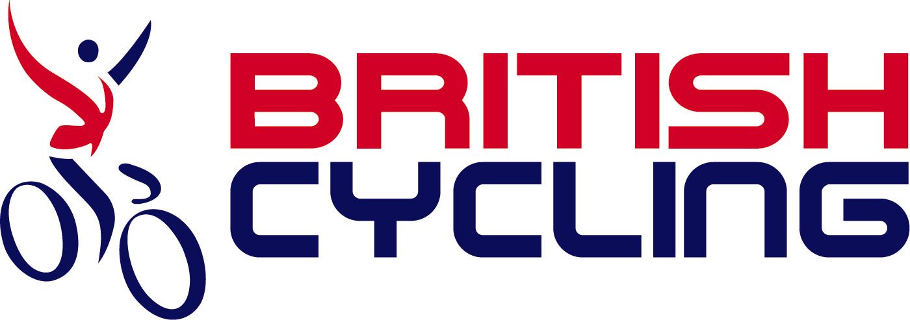

Go-Ride Racing Entry Form

UNDER BRITISH CYCLING’S GO-RIDE RACING TECHNICAL REGULATIONS

Go-Ride Racing is entry level racing for riders U16 with little or no racing experience

To the Organiser: (PLEASE USE BLOCK CAPITALS)

Event Name: | GO RIDE RACING  (AT HARROW WAY COMMUNITY SCHOOL) | Date of Event: | SATURDAY ¹²th FEBRUARY 2011
Event Category: (Please Tick) Closed Road Circuit Cross-Country MTB Cyclo-Cross
Cycle Speedway Track/Grass Track BMX

Date of Birth: |  | Age on Race Day: |  |  |  | I enclose the entry fee of: | £
Date of Birth: |  | Age Category: |  |  |  | I enclose the entry fee of: | £
First Name: |  |  |  | Surname:
Club/School:
Address:
Town: |  |  | County:
Postcode: |  |  | Home Telephone:
E-mail: |  |  | Date Entered:
RIDER DECLARATION
I declare that the information on this form is complete and correct. I understand and agree that I participate in this race entirely at my own risk, that I must rely on my own ability in dealing with all hazards and that I must ride in a manner which is safe for myself and all others. I am aware that when riding in an event the function of the marshals is only to indicate direction and that I must decide if the movement is safe. I agree that no liability whatsoever shall be attached to the , promoting club, meeting sponsor(s), British Cycling, or any official or member of the promoting club in respect of any injury, loss or damage suffered by me in or by reason of the race, however caused.
Signed:
PARENTAL CONSENT
It is necessary to obtain your consent for your child to take part in a Go-Ride Racing event. If you wish your son/daughter to participate, then please read the following information and the rider declaration and then sign the Parental Consent Notice. All British Cycling coaches are fully qualified, have received training in Safeguarding and Protecting Children, and have been checked and cleared through the Criminal Records Bureau. Any information provided about your child will be placed on a database maintained by British Cycling and will be kept confidential and secure. It will only be used for the purpose of contacting you or your child regarding future Go-Ride events and clubs which your child could become involved with. British Cycling may take photographs/video footage during the event. These could be used in coaching resources, presented at Coach Education courses, placed on the British Cycling website, or for general British Cycling publicity purposes. If you do not wish for photographs/video footage of your child to be used, please advise us of this.

NOTES
- Any participants who persistently misbehave or put others in danger will not be allowed to continue and will be asked to leave the event.
- A cycling helmet must be worn at all times during the event.

PARENTAL CONSENT: I declare that I have read the information and the rider declaration and declare that I have the right to give parental consent, and hereby consent to my child taking part in the Go-Ride Racing event.

Signed:
AGE CATEGORIES
XC MTB, Closed Road Circuit, Track/Grass Track, BMX and Cycle Speedway:  U16: Age 15 or younger on January 1st in the year of the race  U14: Age 13 or younger on January 1st in the year of the race  U12: Age 11 or younger on January 1st in the year of the race  U10: Age 9 or younger on January 1st in the year of the race  U8: Age 7 or younger on January 1st in the year of the race |  |  |  |  | Cyclo-Cross:  U16: Age 15 or younger on September 1st in the year of the race  U14: Age 13 or younger on September 1st in the year of the race  U12: Age 11 or younger on September 1st in the year of the race  U10: Age 9 or younger on September 1st in the year of the race  U8: Age 7 or younger on September 1st in the year of the race
ENTRIES WITHOUT CORRECT DETAILS OR SIGNED DECLARATION AND PARENTAL CONSENT WILL NOT BE ACCEPTED





